Initial network capacity check form

Biomethane network entry connections

Capacity Enquiry

Northern Gas Networks has adopted an approach to support producers from conception to completion of their biomethane gas to grid project. From this point onwards, Northern Gas Networks will proactively work with the Producers while they identify, develop, construct and produce their sustainable locally sourced gas projects.
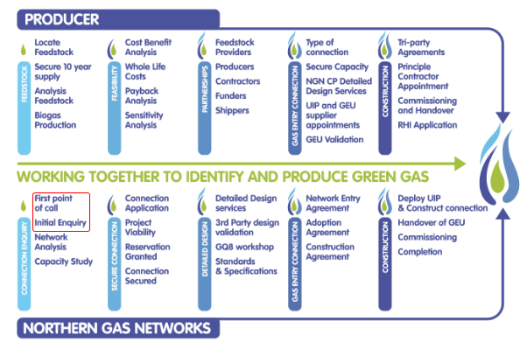

Contact Us
For strategic advice and for gas to grid delivery process information or guidance please contact:
biomethanedoc@northerngas.co.uk
Alternatively, visit Northern Gas Networks dedicated Biomethane website at the following website address: www.biomethane.northerngasnetworks.co.uk

Required Information

Please populate the table below with the information required to undertake the network capacity check. Return to biomethanedoc@northerngas.co.uk

Developer / Producer or Project Manager details
Company / Organisation  Name:  Address: | Contact Details  Name:  Role:  Landline:  Mobile:  Switchboard:  Email:
Date of Application:
Gas to Grid Project Details
Name and address of Project:  Postcode: |  | OS Coordinates  Easting:  Northing:
Site Description. Please provide any additional information on the site location that would help us with your enquiry. |  | Estimated Flow Rate based on (standard cubic metres (SCM) per hour) 24 hours/day, seven days/week injection:  ___ standard cubic metres per hour (scmh)
Electricity production: Will the project produce electricity for the grid? If yes, how much is planned? |  | Gas Extraction. Will gas be extracted from the same network that Biomethane is being injected?
Additional Information / Comments - Please provide any additional information that may help us in your enquiry on the proposed gas to grid project.

